
CS2S567 Professional Practice and Employability Team Based Software Development Workshop
shaily.jain@southwales.ac.uk
Shaily Jain | [Date] | [Course title]

1 Aim of the Module

To introduce core aspects of legal, social, ethical, and professional issues within the framework of a team project using the AGILE methodology.

1.1 Objectives

- Legal issues
  - importance of project requirement definitions on client contracts
  - use of copyrighted material /plagiarism
  - use of IP, securing IP (copyright, patents, trade secrets, trademarks)
  - digital rights management
  - open software
  - software piracy
  - accessibility
- Social issues
  - social implications of computing in a networked world, e.g. privacy, data snooping
  - globalisation
- Ethical issues
  - fair sharing of workload in team, mutual support, whistle blowing (e.g. student not pulling weight)
- Professional issues
  - work "contract" with students
  - Forms of professional credentialing
  - Time to market and cost considerations versus quality professional standards
  - professional communications (technical documents, presentations, shared documents, ...)
  - use of collaboration tools

1.2 What does this all mean?

The Aim and the list of Objectives above look awful: dry, theoretical, boring and not particularly relevant (why do I want to learn that?).

However, in the context of this simulated project you will be applying typical tools that are widely used by employers in the computing industry, e.g. source code control systems and project management / communication systems in the context of the AGILE program development method. These are the real-life 'professional issues' in the Objectives above. Nothing dry and theoretical about them. Tools of the trade - they can even be used for other things than programming, they are transferrable skills.

While you are working on your team project you will naturally encounter and solve many real-life problems such as fairly organising and distributing workload ('social issues'), consequences arising from the company's contract with its customer/client ('legal issues') and consider practical problems such as encryption of data and who has access to the data ('ethical issues'). It is all applied and you will be learning practical work skills.

1.2 Module Setup

In contrast to other modules the content of this module is not primarily technical. Although technology, and especially programming, is an important aspect and although you are likely to learn quite a bit about it, it is only a means to an end here. This end is to introduce you to how computing projects are run in "the real world".

In order to facilitate this we have created a virtual company where you are employed. Brainvire Ltd, is a software systems house and has just won a major new client contract from Ufix Ltd., a major B2B trading company, for the provision of a large suite of programs to facilitate core parts of its internal operations. As a result of this new contract Brainvire Ltd. had to hire a large amount of new programmers. You are one of them. Programmers are assigned to project teams, one for each of Ufix’s application programs.

Just to clean up any misunderstanding:
- You are an employee of Brainvire
- Ufix is a customer of Brainvire
- You are building a software suite for Ufix as an employee of Brainvire.
- You or members of other teams are not the users that will use the software suite you are designing and implementing. The users are the employees of Ufix.
- Neither Brainvire nor Ufix are real companies. They do not exist but we just pretend they do.

Brainvire Ltd. operates in a time warp. While the total project duration is 24 days each project day is equivalent to a full University teaching week.

Your lecturers also play roles. Sometimes they will appear as your boss, for example to assess your performance and pay scale (i.e. give you marks). Sometimes they appear as a representative of the client, Ufix Ltd., to discuss the finer details of the project requirement definitions with project teams. Both roles also exist in projects in the real world - and the views and instructions of the two are not necessarily compatible (another 'professional issue').

2 Presentations/ SEMINAR

Apart from the lectures there are Students seminars, exactly as in real-life companies. In seminars employees update each other on team progress, receive feedback from others, discuss things and also teach others new skills.

Therefore, over the duration of this module every team will prepare and hold a set of seminar presentations. These not only satisfy a specific technical requirement (e.g. progress reports to inform other teams) but are also intended as training within the modules 'professional practice and employability' remit. It will be marked as Demo and every team member should make every effort to attend it.

Presentations come in three flavours:
- Team task presentations( Phase 1)
- Specific topic Team progress reports( Phase 2)
- presentations and final work (Phase 3)

2.1 Team Task Presentations

Team task presentations PowerPoint presentations followed by a 5 minute Q&A session. These presentations are given during the first phase of development of the module. Experience suggests that about 8 to 12 slides are adequate to fill the 20 minutes.

Each team member is expected to contribute something to the presentation (and document this in their portfolio). This contribution could be background research, slide design, rehearsal director and main critic, demo program writing, handout production, etc. There can be as many presenters as the team wishes - one, all or any number in between.

The presentations are given for the benefit of the other groups so that these know:
- The task of the team in general
- Contact details (e.g. e-mail addresses) of team members so that they can get in touch
- The specifics of your team's task and their contact points with other teams
- Work and progress done so far

At the end of the presentation there will be a 5 minute Q&A session where other teams can ask questions, make suggestions, point out potential problems, etc.

Each slide should have its 'notes' completed. The notes could include:
- your contact details (notes underneath the title slide)
- the content of what was said by team members during the presentation
- response to comments by other teams

BEFORE the presentation e-mail your lecturer the slides so that he can give you feedback and put them on Blackboard for other teams to see.

AFTER the presentation and following the feedback and comments from other teams update your slides and again e-mail them to your lecturer for publication on Blackboard.

2.2 Specific topic and Progress Reports

Progress Reports presentations given during the second phase of project. Your team will produce work reports. The team presentation is then followed by a 5 minute Q&A session where other teams can ask questions, provide suggestions, criticise, etc.
Also include a talk about a software tool or project management tool you enjoyed working with. For example :- Agile , Scrum , trello, Git Hub .

For reporting your team could use PowerPoint slides, projections from a laptop onto screen, handouts, or any other aids that spring to mind.

Each team member should present some of the material.

BEFORE the presentation e-mail your lecturer the slides so that he can give you feedback and put them on Blackboard for other teams to see.

AFTER the presentation and following the feedback and comments from other teams update your slides and again e-mail them to your lecturer for publication on Blackboard. In the following week send the Word document on the topic.

2.3 final work (Phase 3)
Final work presentations given during the third phase of project. Your team will produce work reports of final work . The team presentation is then followed by a 5 minute Q&A session where other teams can ask questions, provide suggestions, criticise, etc.

For reporting your team could use PowerPoint slides, projections from a laptop onto screen, handouts, or any other aids that spring to mind.

Each team member should present some of the material.

BEFORE the presentation e-mail your lecturer the slides so that he can give you feedback and put them on Blackboard for other teams to see.

AFTER the presentation and following the feedback and comments from other teams update your slides and again e-mail them to your lecturer for publication on Blackboard. In the following week send the Word document on the topic.

3.1 Fair allocation of individuals' workloads in teams:
- Taking on tasks within the team is critical but tasks are only allocated by the team if the individual team member agrees (if unsure this could be done on a tentative -> agree basis)
- Task allocation follows the "who does what by when" method.
- If the 'by when' part becomes problematic (i.e. a team member is unable to meet the deadline) this should be flagged-up as early as possible to the team to resolve it by providing peer help or task re-allocation (caveat: as already said above this must be voluntarily).
- Individual team members must not "steal" tasks allocated to other team members (a problem found usually in stronger students) and will get penalised for doing so since "stealing" leads inevitably to disengagement of the "robbed" team member.

3.2 Correct allocation of individual contributions to team effort
- Code sharing between teams and individuals is encouraged. Both the donor and the receiver specify and document this in their Portfolios and both are rewarded equally.
- The actual outcome of a team's effort is not assessed / marked, even if it is a total failure. Only individual effort is assessed on quality, quantity, timeliness and regularity of, for example:
  - issue tracking
  - bug reports
  - team task contribution
  - QA process involvement (report, replicate, respond, resolve)

3.3 Team dynamics / exclusion of team members
- Teams have no team leader and/or hierarchy allocated, but if a leader emerges in a democratic way that's fine.
- Conflict resolution is the responsibility of the whole team.

3.4 Ensuring equal opportunities for team members
- The lecturer based on various skills assembles teams.
- Attendance at team meetings, module lab sessions, seminars, etc can't be enforced but it should be very clear that it is expected.
- Communication and project progress are primarily documented via a professional communications tool (e.g. Trello). Screen shots taken from the tool are useful for providing evidence / verification for individual coursework Portfolios.
4. Project Understanding
To understand the team it is important to know about Project. Your company Brainvire is designing a software system that is very important for your Company’s Client Ufix. Ufix Ltd is a training company. For the smooth and efficient running of the company Ufix decided to have a HR SYSTEM. Brainvire Ltd your employee, hire 60 programmers to design the system.
System is divided into Following Teams: - In 6 Different Modules. Each Module will be designing, programming and implementing by 6 teams.

HR SYSTEM
Team 1 SYSTEM Admin
Team 2
Personal Information management
Team 3
Leave Information System
Team 4
Payroll
Team 5
Recruitment /Training
Team 6
Assets /Disciplinary

As shown in the figure on the previous page, Module 1(team) and Module 2 (team) are at the heart of the suite of programs. Every team will have to liaise with these two teams but of course also with a several other teams.

A representative of the client, Ufix., will be available during the stages of the project.

The need for documentation is not mentioned in the individual preliminary project requirement definitions in this chapter since this need applies to all project teams. All personal team documentations (meeting notes, technical drawings, UML diagrams, Gantt charts, test documents, user manuals, etc) are stored in the coursework Portfolios.

Each team has to document its work, i.e. produce at a minimum a thorough program documentation and a test documentation.

Each team has to produce a user manual for the program it has produced.

Each team has to produce a team Gantt chart so that other teams can figure out what will be ready by when and coordinate their own progress accordingly.

Team Building: - This is based on the number of students we have in each group.

5. The Systems Administration (Team 1)

This module is the central point to access and control your core HR functions.
This is one of the two core systems (the other one being the information management system produced by team 2). Every other team will have to liaise with this team.

This team's preliminary tasks (in order of time importance) are:

- Research and implement a way in which the programs of all other teams can be deployed together.

Initially we keep things simple: Each team produces its own executable and reads/write all data its program produces locally to a data file. This allows teams to make progress while Team 1 explores a more advanced solution.

Possible solution alternatives might be:
- Suggestion Could be Github , Blackboard as well
- 2. Once a basic system is in place roll it out to all teams. Remember that you have to provide to all other teams’ clear instructions and/or example code how to use your setup.

- More demands and requirements will now come in from other teams, e.g. provide a program for managing password protected access to only parts of the programs and/or data.

- You will also create a call out IT service login system for all UFIX employees.

6. Personal Information Management: - (Team 2 )
In this system Ufix Ltd will know all information about their staff, but for protection only assign members can access the system. This system will keep the record of all staff but with special credential and logins.

Simplify and streamline your HR data with Personal Information Management (PIM) module, helping you centralize all your employee data.

This is the second of the 2 core systems Every other team will have to liaise with this team. The system developed by this team is regulating access to the programs of all other teams (and itself) and will be used by the company's management, e.g. for granting certain access rights, setting salary levels, etc. Think about how access can be protected. Should it be encrypted? Which interactions will require confirmation by a second or third person?

This team's preliminary tasks (in order of time importance) are:Setup a simple overall user interface from which all other team programs can start. To begin with this could be a single window with a button to launch each team's program. A possible layout could be something like this for example or you can as creative as you want :-

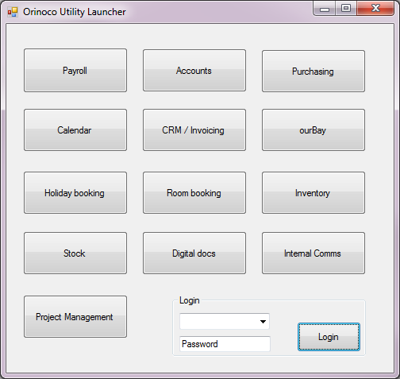

).

7. Leave Management System: - Team 3
The ability to manage leave and create multiple leave types depending on UFIX’S policies . Leave Management System enables to staff to create multiple leave types such as Vacation, Sick, FMLA, Maternity, Family Care Leave, Child Care Leave quickly and easily. You can configure rules regulating these leave types with company and state polices – ensuring you are always compliant
You can also setup accruals and carry forwards to run at configurable intervals and accumulate leave based on employment status, job titles, service period, gender and job category.
Working weekend and Static work week
- Enable managers to set fixed company holiday dates (e.g. Easter, Christmas, etc)
- Drag standard UK bank holiday dates from the internet and use them in the system
- Allow employees to request holiday. Leave requests have to be signed off by the employee's respective line manager. Only the boss has no line manager and can do what she pleases (husbands know this). The system of team 2(PM) will tell you who manages whom.
- Allow managers to see the holidays of the people they manage so that they have an overview and can manage accordingly. The boss, of course, sees all.
- Holiday bookings should be flexible, i.e. it should be possible to change dates or to cancel a holiday if necessary. Again, changes have to be signed off by the line manager.
- Ideally the system should inform employees in good time before the end of the year that they are in danger to lose holiday days if they don't book soon. Only a management defined amount of days can be rolled over to the next year, the rest is lost and is not compensated in pay.
- Allow for the booking of sick leave and maternity/paternity leave.
8.Payroll (Team 4)

It is likely that most teams (but probably not all) will have to liaise with the team that is implementing the Payroll program since this program will maintain the list of company employees and their respective roles, e-mail addresses, etc.

This team's preliminary tasks (in order of time importance) are:

- Setup a list or database of company employees (names, e-mail addresses, bank details, etc). This could be a real database or just a cleverly designed list or text file. Up to you. Keep this flexible as other teams may ask you to add more information.( Team 2 can be help full )
- Provide an access facility to these data for other teams who may need them for their own programs. This will require handling of access rights so you will have to liaise with team 2: Admin / Access. Not every team or employee will be allowed to see, edit, add, delete data and certain changes will have to be signed off by management (ie. the team 2 system).
- Set up a facility to perform monthly pay runs so that every employee will get paid in time. Bear in mind that people might start halfway through a month so they may not receive the full pay.
- Research the legal requirements. If the company has £100 to pay an employee how much of this goes to HMRC (the so called 'employers contribution'). Make the system flexible as Tax code changes time to time depending on Employees personal Circumstances.
- Team 4 (Accounts) will have to receive the data generated by each payroll run.
- Employees may claim expenses (travel, accommodation, etc) and that has to be re-imbursed via the pay run - but expenses do not attract tax, NI or pension payments.
- Monthly payslips for each employee (and their P60s at the end of the year) should be stored with other team so that employees can see and/or print them out.

More demands may come from the client representative and/or from the other teams.

9. Recruitment and Training system:- Team 5

1.Candidate sourcing is an integral part of your search for talent, it does not matter how big your pool is if you do not attract quality performers who are not looking for work. Create a data base of a talented people.

2. Create structured interviews with intelligent automated question prompting based on difficulty or go old school and use the system to rate candidate responses. Create a test

3. Drive your decision on industry standards with the use of personality insights and predictive analytics. Find similar achievers and best matches for the position.

4. Images and Copyright data, you need to careful with. Use advance tool option to capture images from Google.
5. Your team is also responsible to arrange necessary trainings like:- Induction/ Data protection/ company IT policy /

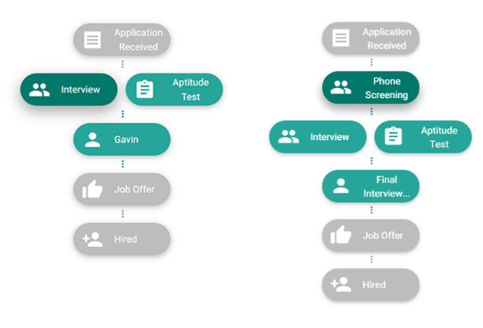

10..Disciplinary /Asset tracking System: - Team 6
Asset Tracker module offers exceptional value to managers and administrative users. Improve operational efficiency, tighten inventory control and maintain detailed asset information and status with this robust inventory management module.
      - Create inventory of Ufix’s company’s assets.
      - A system that can help tracking of assets that include company’s room hire and laptops used by staff.
      - It is important to document all steps associated with handling discipline with staff. Now with the system you create can track and maintain all cases and actions with ease. Like Misuse of Company’s property.
      - http://www.acas.org.uk/index.aspx?articleid=1439

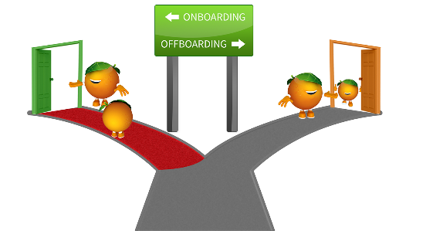

.

A B2B company trades only with other companies (Business-to-Business). They rarely have web sites but provide their customers with plugins into their ordering system while they in turn use plugins from their suppliers into their own system. This facilitates tight integration and important properties such as just-in-time delivery.

